The Fed and inflation

美联储和通货膨胀

（英文部分选自经济学人20220618期财经版块）

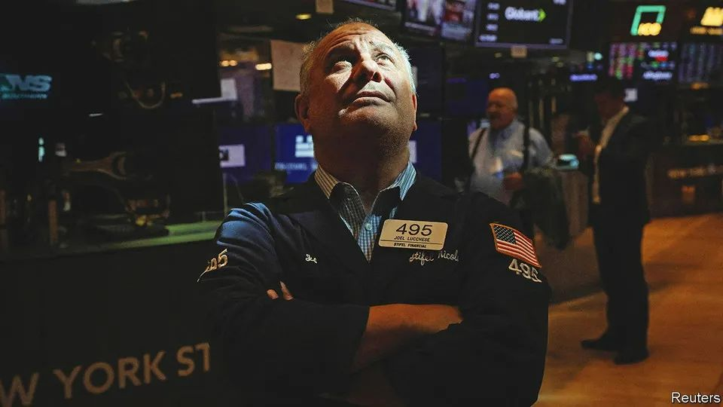

The Fed and inflation

美联储和通货膨胀

Eight days that shook the markets

市场震荡的八天

Investors **wake up to the fact that** conquering inflation will be painful

投资者清醒认识到：征服通胀之旅，注定苦不堪言

“I do not expect moves of this size to be common,” said Jerome Powell, chairman of the Federal Reserve, on June 15th. The central bank had just raised its benchmark interest rate by 75 basis points (0.75 percentage points) to 1.5%-1.75%. It was the third increase in as many meetings and the biggest jump in short-term rates since 1994. The move was both expected and surprising. Mr Powell had warmed up markets weeks ago to the prospect of a 50-basis-point increase at this monetary-policy meeting. But in the days **leading up to it**, investors had quickly and fully priced in a larger rise—with more to come.

6月15日，美联储主席杰罗姆·鲍威尔（Jerome Powell）说，“我不认为今后我们会频繁进行如此大幅的加息。”近日，美国中央银行将基准利率上调75个基点（0.75个百分点）至1.5％-1.75％。最近的美联储，三次开会，三次加息，而此次的调整幅度创1994年以来的新高。这一动作，看似意料之外，却又在情理之中。几周前，鲍威尔先生就已经给市场吹了风，透露在本次货币政策会议上或将上调50个基点。但是，在会议前几天，市场的迅速而大幅的回调反映出投资者的悲观预期：此次调整幅度或将更大，而加息的脚步也不会止步于此。

Mr Powell’s comment about uncommonly large increases was enough to spark a partial reversal of the sharp rise in bond yields over the preceding days and a relief rally in share prices. But however much he tried to sugar-coat the message, rates are going up by a lot more and the chances of a hard landing for the economy have surely increased as a consequence. Recession is now more widely expected, if not (yet) by the Fed. And the rapid changes in the market mood show just how much the Fed and other rich-world central banks have lost control of events.

鲍威尔先生大幅加息不会频繁的言论足以在一定程度上逆转前几日债券收益率的大幅增长，也能让股价出现暂时反弹。但不论他如何努力地美化消息，利率陡增已是板上钉钉，经济硬着陆的风险也必然增大。如今，人们普遍倾向于预期经济衰退即将到来，即便美联储尚未认同这一点。市场情绪的急剧波动表明事情已脱离美联储和其他富裕国家央行的掌控。

The Fed’s interest-rate decision came at the end of an extraordinary few days in financial markets, in which bond yields shot up at a violent rate, share prices plunged and riskier assets, notably bitcoin but also Italian government bonds, were trashed. The story begins not in Washington or New York but in Sydney where, on June 7th, the Reserve Bank of Australia raised its benchmark interest rate by 50 basis points, citing growing worries about inflation. It continued in Amsterdam, where in the following days the European Central Bank (ecb) held its monetary-policy meeting, in a break from its usual setting in Frankfurt. Christine Lagarde, the central bank’s boss, confirmed that a 25-basis-point rate increase would be on the cards in July. But she went much further. The ecb, she said, expects to raise interest rates perhaps by 50 basis points in September and anticipates “sustained” increases thereafter. The catalyst for this more hawkish stance was a sharp upward revision in the central bank’s forecasts for inflation.

美联储公布此次加息决定之前，金融市场就已经经历了几天非比寻常的行情：债券收益率大幅上涨、股价暴跌、风险更高的资产，尤其是比特币（当然也包括意大利国债），更是遭遇重创。此次事件的始作俑者不在华盛顿，不在纽约，而是远在悉尼。6月7日，考虑到日益加剧的通胀担忧，澳大利亚储备银行将其基准利率上调了50个基点。接下来阵地转移到阿姆斯特丹：之后几天欧洲央行在此处举行了货币政策会议，打破了其在法兰克福总部召开会议的惯例。央行行长克里斯蒂娜·拉加德（Christine Lagarde）证实，7月或将加息25个基点。在此基础上，她进一步表示，欧洲央行预计9月将再次加息50个基点，且此后可能会持续加息。央行对通胀预期的大幅上调是此次更为鹰派立场的催化剂。

This set the stage for a dramatic shift in bond markets, which events elsewhere added impetus to. The yield on ten-year German government bonds, known as bunds, rose quickly to above 1.75% over the following days. The yield on riskier sorts of euro-zone government bonds, notably Italian btps, rose by even more. The spread (excess yield) on btps over bunds widened sharply, taking Italy’s ten-year yield above 4%. Indeed spreads had risen so swiftly that the ecb’s rate-setting council held an emergency meeting on June 15th to address the matter (see next story).

这为债券市场的戏剧性转变奠定了基础，而其他市场上发生的事情为这种转变提供了动力。在随后几天里，10年期德国国债（Bund）收益率快速升至1.75%以上。风险较高的欧元区政府债券，尤其是意大利国债（BTP），收益率涨幅更大。意大利国债和德国国债的利差（超额收益）急剧扩大，推动10年期意大利国债收益率超过4%。实际上，利差上升得如此迅速，以至于欧央行管理委员会于6月15日召开了一次紧急会议来解决该问题（见下一篇报道）注释：欧央行紧急会议：

But it was news from America that really moved markets. Figures released on Friday June 10th showed that annual consumer-price inflation rose to 8.6% in May, the highest rate since 1981. Underlying price (“core”) pressures were unexpectedly strong. To make matters worse, a survey by the University of Michigan showed that consumers’ expectations of medium-term inflation had risen markedly. Taken together, the reports suggested that inflation would be much harder to bring down.

但真正引发市场动荡的消息源自美国。6月10日周五公布的数据显示，5月消费者价格指数同比上涨 8.6%，为 1981年以来最高水平。核心通胀压力出乎意料的强劲。更糟糕的是，密歇根大学的一项调查显示，消费者对中期通胀的预期显著上升。综合来看，这些报告无一不在表明，通胀水平压降难度陡增。

注释：美国5月CPI：6月10日，美国劳工统计局公布数据显示，美国CPI同比上涨8.6%，创1981年12月以来新高，并高于上月及预期的8.3%增幅；CPI环比增长1%，显著高于预期的0.7%和上月的0.3%。核心CPI同比上涨6%，较上月的6.2%有所回落，但依然高于预期的5.9%；核心CPI环比增长0.6%，与上月增幅持平，但高于预期的0.5%。本次CPI之所以引发市场剧烈震荡，主要是因为它完全改变了此前投资者对于通胀筑顶回落的路径预期。

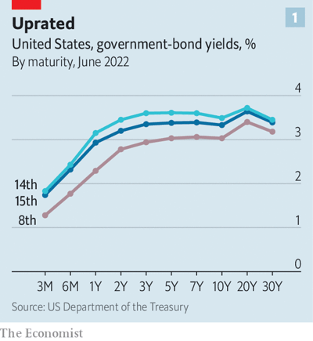

Treasury yields rose sharply as the bond market began to price in more and faster interest-rate increases by the Fed. The biggest moves were at the short end of the yield curve, which is most sensitive to shifts in monetary policy. Yields on two-year Treasuries rose by 57 basis points in the space of just two trading days. But longer-term rates shifted, too (see chart 1).

随着债券市场开始定价美联储更大幅度和更快的加息行动，美国国债收益率飙升。最大的波动来自收益率曲线的短端，这部分对于货币政策的变动最为敏感。2年期美国国债收益率在两个交易日内上升了57个基点。但更长期限的利率同样发生了变化（见图1）。

Stocks could hardly escape the reckoning (see chart 2). The s&p 500 index of leading shares fell by 3% on June 10th and by 4% the following Monday. The cumulative losses took the stockmarket firmly into bear-market territory, defined as a fall of more than 20% from its recent peak. The tech-heavy NASDAQ index has fallen by even more. Higher Treasury yields have weighed on share prices, but have been a fillip to the dollar. The dxy, an index of the greenback against half a dozen rich-world currencies, is up by 10% this year. The strength is particularly marked against the yen, which has fallen to a new 24-year low. While the Fed is tightening policy to bring down inflation, Japan’s central bank is furiously buying bonds in order to raise it.

股市也难逃此劫（见表2）。标普500 在6月10号下跌了3%，并在接下来的周一又下跌了4%。这累计的损失将股市妥妥带入了熊市，即从最近的高点已下跌了超过20%。而重仓科技股的纳斯达克指数下跌的更多。更高的国债收益率给股价施加了压力，但是对美元起到了刺激作用。DXY指数，一个美元对六种富裕国家货币的指数，今年已上涨10%，美元的强势在对比日元时显得尤为明显，日元已跌至24年来的新低。当美联储收紧政策以降低通胀时，日本央行却在疯狂购买债券以提高通胀水平。

If you say that you will have a reckoning with someone, you mean that you will face them at some time in the future and punish them for something they have done. The recent volatility, particularly in the bond market, has been quite extreme. What might explain this? As bad as the inflation backdrop had seemed before last week, investors had consoled themselves with the idea that the worst of it was now in the past. The Bank of America’s global fund-manager survey suggests that in recent weeks, investors had increased their allocation to bonds—perhaps judging that bond prices had stopped falling. (Bond prices move inversely to yields.) If so, the poor inflation figures **caught them out**.

最近的市场波动已经非常极端，尤其是在债券市场。那要如何解释现在这样的现象呢？尽管通胀背景在上周以前看起来已经相当糟糕，但投资者们安慰自己最差的阶段已经过去。美国银行的全球基金经理调查表示，最近几周投资者们已增加对债券的配置——可能他们判断债券价格已经停止下跌。（债券价格和债券收益率呈反比）如果是这样，糟糕的通胀数据会让他们发现大错特错。

A market that leans heavily in one direction often snaps back when the wind changes. And poor liquidity amplifies the effect. Changes in regulation have made it costlier for banks to hold large inventories of bonds to facilitate client trading. The Fed, once a reliable buyer of Treasuries, is winding down its purchases. When investors want to sell, there are too few willing to take the other side of the trade. The violent market moves in the days leading up to the Fed meeting may have exaggerated the sense of panic.

当市场严重向一个方向倾斜时，风向的变化会导致迅速的反弹。而匮乏的流动性会放大这一效应。监管的变化已经加大了银行持有大量债券以方便客户交易的成本。美联储，曾经可靠的债券买家，现在正在减少买入。当投资者们想要抛售时，很少有人愿意站在交易的另一边（买入）。在美联储开会前几日里的市场波动或加剧这方面的恐慌情绪。

Yet it is hard to argue that investors are bullish. The Bank of America survey shows that optimism among fund managers about the economic outlook is at an all-time low. Can a hard landing be avoided? Even Mr Powell sounded rather unconvinced. Prepare for more trouble ahead.

但是现在很难说投资者们是看涨的，美国银行的调查显示基金经理们对于经济前景的乐观程度已经处于历史最低点。我们还能否避免**经济的硬着陆**，这同样也是一个困扰着鲍威尔的问题。未来有更多的艰难险阻需要我们面对。

